**Module Title: -Apply Business Technology**

**UNIT ONE: SELECT AND USE TECHNOLOGY**

* 1. **SELECT** **TECHNOLOGY AND** **SOFTWARE APPLICATIONS**
     1. **OVERVIEW TECHNOLOGY**

The word “technology” refers to the study of applied techniques. For example, the development of the most advanced devices such as an Android requires the use of multiple techniques from different disciplines to achieve the common goal.

Of course, since there are different disciplines, this implies that each one of them has its own types of technology or its different studies of techniques according to its purpose. And certainly, there are many types of technology, which will be our point of interest here.

Technology, the application of scientific knowledge to the practical aims of human life or, as it is sometimes phrased, to the change and manipulation of the human [environment](https://www.britannica.com/science/environment). Technology has a tremendous impact on the life style, consumption pattern, and the economic well-being.

Introducing new technology, such as a computer or cell phone, into a business helps to improve productivity and product innovation. In small businesses, simple Technology is constantly changing the demands of consumers. Businesses use new technologies to produce new products and services.

Technology has a tremendous impact on the life style, consumption pattern, and the economic well-being.

Technology is a mixed blessing in other ways also. A new technology may improve the live in one area while creating environmental and social problems in other areas.

Technological breakthroughs can affect markets in three ways:

* Start entirely new industries, as computers, robots have done
* Radically alter, or virtually destroy, existing industries.
* Stimulate markets and industries not related to the new technology.

**Types of Technology**

A computer system composed of components that are classified either as Computer hardware or Computer software. The two types of technologies are

1. **Hard Technology**
2. **Soft Technology**
3. **Hard Technology**

**Hard technology** refers to tangible, physical devices, tools, or equipment that have a fixed application or function.

**Characteristics**:

* Concrete and material in nature.
* Often involves machinery, hardware, or equipment.
* Operates independently of human skills once designed and implemented.
* Focuses on solving specific, technical problems.

**Examples**:

* Robots in manufacturing.
* Computers and electronic devices.
* Automobiles and airplanes.
* Medical devices like MRI machines.

**Advantages**:

* Precision and reliability in repetitive tasks.
* Can operate in hazardous or high-demand environments.
* Reduces human effort and increases efficiency.

**Limitations**:

* High initial cost and maintenance requirements.
* Limited flexibility; designed for specific tasks.

Hard technology cannot exist without soft technology; and soft technology becomes meaningless if hard technology does not exist. The disciplines that mainly develop this type of technology are electronics, mechatronics, metallurgy, mechanics, chemistry, architecture, textiles, among others.

Computer hardware includes all the electrical, mechanical, and the electronic parts of a computer. Any part that we can see or touch. These are

* 1. **System Unit**

Key components inside a System Unit

* **Central Processing Unit (CPU)**: The brain of the computer.
* **Motherboard**: Connects all components and peripherals.
* **RAM (Random Access Memory)**: Temporary storage for active processes.
* **Storage Devices**: Hard drives (HDD) or solid-state drives (SSD).
* **Power Supply Unit (PSU)**: Provides electricity to components.
* **Cooling Systems**: Fans or liquid cooling for temperature control
  1. **Peripheral devices**

The system unit of a computer refers to the main body of a desktop or tower computer, housing key internal components like the processor, memory, and storage. It excludes peripherals like the monitor, keyboard, and mouse. Here are examples and their types:

**Types of Peripheral Devices**

1. **Input Devices**
   * Used to provide data and control signals to the computer.
   * Examples:
     + **Keyboard**: For typing and command inputs.
     + **Mouse**: For point-and-click interactions.
     + **Scanner**: Converts physical documents or images into digital format.
     + **Microphone**: Captures audio input.
     + **Game Controller/Joystick**: For gaming interactions.
     + **Digital Camera**: Transfers images or videos to the computer.
2. **Output Devices**

* Used to convey processed data from the computer to the user.
* Examples**:**
  + **Monitor**: Displays visual output (e.g., LCD, LED screens).
  + **Printer**: Produces physical copies of digital documents or images.
  + **Speakers**: Outputs sound from the computer.
  + **Headphones**: Provides audio output for personal use.
  + **Projector**: Enlarges the computer display onto a screen or wall.

1. **Input/Output (I/O) Devices**

* Perform both input and output functions.
* Examples**:**
  + **Touchscreen**: Acts as both an input device (via touch) and an output device (displaying visuals).
  + **External Hard Drive**: Allows data transfer to/from the computer.
  + **USB Drive**: Portable storage for data transfer.
  + **External CD/DVD Drive**: Reads and writes to optical disks.

1. **Storage Devices**

* Facilitate additional storage or portability of data.
* Examples:
* External Hard Drives: For large-capacity storage.
* Flash Drives (USB Drives): Compact and portable storage.
* Memory Cards (SD Cards): Used in cameras, smartphones, and computers.
* Network Attached Storage (NAS): Provides shared storage over a network.

Peripheral devices enhance the functionality of a computer by enabling it to interact with the user and the external world. They are essential for inputting, processing, and outputting data, making them critical components in computing systems.

1. **Soft Technology**

**Soft technology** refers to intangible tools, methods, knowledge, or processes that are designed to enhance human efficiency, problem-solving, and decision-making. Unlike hard technology, which involves physical tools or devices, soft technology is focused on systems, skills, and strategies.

**Characteristics of Soft Technology**

1. **Intangible Nature**: It deals with processes, systems, and methodologies rather than physical hardware.
2. **Human-Centric**: Relies on human expertise, creativity, and adaptability.
3. **Dynamic and Flexible**: Easily modifiable to suit different contexts or environments.
4. **Service-Oriented**: Often applied in fields like education, management, healthcare, and social systems.

**Examples of Soft Technology**

1. **Management Systems**:
   * Total Quality Management (TQM).
2. **Educational Systems**:
   * E-learning platforms..
3. **Marketing Strategies**:
   * Digital marketing techniques (SEO, influencer marketing).
4. **Environmental Strategies**:
   * Recycling and waste management processes.

**Advantages of Soft Technology**

1. **Adaptability**: Can be tailored to different industries and needs.
2. **Cost-Effectiveness**: Often less expensive than developing hard technologies.
3. **Empowers Innovation**: Encourages creativity and process improvements.
4. **Enhances Human Interaction**: Focused on optimizing workflows and communication.

**Limitations of Soft Technology**

1. **Dependency on Skills**: Effectiveness depends heavily on the expertise of users.
2. **Intangible Nature**: Difficult to measure or evaluate outcomes precisely.
3. **Implementation Challenges**: Requires training and acceptance from users.

**Applications of Soft Technology**

Soft technology is widely used in areas requiring creativity, adaptability, and strategic thinking, such as:

* **Business**: Enhancing organizational efficiency through management systems.
* **Education**: Improving teaching methods and learner engagement.
* **Healthcare**: Managing patient care and optimizing treatment processes.
* **Environment**: Designing sustainable practices for communities.

By complementing hard technologies, soft technology plays a crucial role in advancing industries and improving systems globally.

* + 1. **BUSINESS TECHNOLOGY**

**Business technology** refers to the tools, systems, and processes that organizations use to improve efficiency, productivity, and overall performance. It includes both tangible and intangible technologies designed to solve business problems, streamline operations, and create competitive advantages.

**Key Components of Business Technology**

1. **Information Technology (IT)**
   * Encompasses hardware, software, networks, and data systems used to manage and process information.
   * **Examples**:
     + Enterprise Resource Planning (ERP) systems.
     + Customer Relationship Management (CRM) software.
     + Data storage solutions (cloud computing, databases).
2. **Communication Technology**
   * Tools and platforms that facilitate internal and external communication.
   * **Examples**:
     + Email and messaging platforms (e.g., Slack, Microsoft Teams).
     + Video conferencing tools (e.g., Zoom, Google Meet).
     + VoIP systems for business calls.
3. **Operational Technology**
   * Systems and tools that improve the efficiency of business operations.
   * **Examples**:
     + Automated production lines.
     + Supply chain management software.
     + Workflow automation tools.
4. **Customer-Facing Technology**
   * Technology used to enhance the customer experience.
   * **Examples**:
     + E-commerce platforms (e.g., Shopify, WooCommerce).
     + Mobile applications for customer interaction.
     + Chatbots and virtual assistants for customer support.
5. **Financial Technology (FinTech)**
   * Tools and systems used for managing financial processes and transactions.
   * **Examples**:
     + Online payment systems (e.g., PayPal, Stripe).
     + Accounting software (e.g., QuickBooks, Xero).
     + Budgeting and forecasting tools.

**1.1.3 TYPES OF BUSINESS TECHNOLOGY**

These technologies can be categorized based on their function and application within an organization. Below are the key types of business technology:

**1. Communication Technology**

Facilitates interaction and collaboration between employees, customers, and stakeholders.

* **Examples**:
  + Email platforms (e.g., Gmail, Outlook).
  + Video conferencing software (e.g., Zoom, Google Meet, Webex).

**2. Information Technology (IT)**

Focuses on managing, processing, and storing data to support decision-making and operations.

* **Examples**:
  + Data management systems (e.g., databases, SQL, Oracle).
  + Cloud computing platforms (e.g., AWS, Google Cloud, Microsoft Azure).
  + Cybersecurity tools (e.g., firewalls, antivirus software, encryption tools).

**3. Productivity Technology**

Enhances efficiency and organization by streamlining workflows and managing tasks.

* **Examples**:
  + Office suites (e.g., Microsoft Office, Google Workspace).

**4. E-Commerce Technology**

Supports online sales, payments, and customer management for businesses.

* **Examples**:
  + E-commerce platforms (e.g., Shopify, WooCommerce, Magento).
  + Payment solutions (e.g., PayPal, Stripe).

**5. Computers**

Computers are utilized in a variety of enterprises. They have software that allows them to execute a wide range of tasks such as analyzing financial information, sending and receiving emails, and designing sales presentations. The computer is available as a desktop computer or a portable laptop for use in the office or when traveling.

1. **Software**

To do specific activities, computers need several types of software, which include applications and operating information. [Microsoft Word](https://www.microsoft.com/en-in/microsoft-365/word), a word processing package, and [Microsoft Excel](https://www.microsoft.com/en-ww/microsoft-365/excel), a financial spreadsheet system, are used by businesses. [Microsoft PowerPoint](https://www.microsoft.com/en-in/microsoft-365/powerpoint) and [Apple Keynote](https://www.apple.com/in/keynote/) are also used to create professional-looking sales presentations fast and easily. Businesses utilize software that is tailored to their requirements.

1. **Networking**

Networking is a method of interacting with groups of people in order to share information and documents, store data and send emails. It also enables the sharing of a printer or storage device between PCs. A network might be limited to computers within a single office or connected to multiple offices. Businesses need networking since it allows them to form contacts with others in their connected sectors in order to find new clients and partners, as well as expand.

1. **Telephone Communication**

Establishing commercial ties requires effective communication. As a result, businesses connect with customers and organizations via a telephone system. This allows for quick, efficient, and personal dealing with customers. Great customer service and effective communication with your staff will help your company develop a strong reputation and expand in the long run. There are currently commercial telephone systems that have a number of functions to meet a company's demands.

1. **Accounting System**

An accounting system allows organizations to keep track of their expenses and revenue. Small businesses are the most common users of [Quick books](https://quickbooks.intuit.com/in/). It's easy to set up and maintain. Larger businesses, on the other hand, use more flexibility and system connectivity. The ideal accounting system for your company is determined by its size and needs. Before making a decision, it's a good idea to talk to your accountant about your possibilities.

1. **Inventory Control System**

An [inventory control system](https://www.inc.com/encyclopedia/inventory-control-systems.html#:~:text=An%20inventory%20control%20system%20is,storage%2C%20turnover%2C%20and%20reordering.) is used to manage a company's whole inventory. It accurately keeps track of products, including how much inventory is in stock, updating the system when the new inventory arrives as well as when it is sold, and keeping detailed records. To keep the proper balance of things in their warehouse, understand what they have, and examine their finances; businesses need an adequate and organized system to manage their inventory.

1. **Customer Relationship Management Systems**

A [Customer Relationship Management (CRM)](https://www.salesforce.com/in/crm/what-is-crm/) System keeps track of a customer's interactions with your business. The CRM system will track the customer's interactions with you from the minute you get information about them. When a customer calls to order a product or service or to ask for assistance or a technical query, the CRM system will tell the service representative when the items were shipped, what is back-ordered, and any previous discussions the customer has had with your organization.

**1.1.4 BENEFITS OF BUSINESS TECHNOLOGY**

1. **Increased Productivity**
   * Automation of repetitive tasks reduces manual effort and saves time.
   * Real-time data access helps in quicker decision-making.
2. **Enhanced Communication**
   * Seamless collaboration across teams and locations via digital tools.
   * Improved customer interaction through personalized communication platforms.
3. **Cost Savings**
   * Reduces overhead costs by optimizing operations and minimizing waste.
   * Enables remote work, reducing office space needs.
4. **Better Decision-Making**
   * Data analytics and reporting tools provide insights for informed business strategies.
5. **Improved Customer Experience**
   * Faster service delivery and better engagement tools enhance satisfaction.

**1.1.5 APPLICATION SOFTWARE**

**Definition**  
Application software refers to computer programs designed to perform specific tasks or solve particular problems for end-users. Unlike system software, which manages and operates computer hardware, **application software** directly caters to user needs and tasks. Applications sit on top of systems software because they are unable to run without the operating system and [system utilities](https://www.webopedia.com/definitions/system/).

Software applications may include

* Email
* Database
* Internet
* Word processing
* Spreadsheet

**Examples of Application Software**

|  |  |
| --- | --- |
| **Category** | **Examples** |
| Office Productivity | Microsoft Office Suite, Google Workspace |
| Graphic Design | Adobe Photoshop, CorelDRAW |
| WebBrowsing | Google Chrome, Mozilla Firefox |
| Social Media | Facebook, Instagram, LinkedIn |
| Business Tools | Salesforce, QuickBooks |
| Gaming | Steam, Fortnite, Call of Duty |
| Education | Coursera, Zoom, Blackboard |
| Media Playback | VLC Media Player, Spotify |

**Advantages of Application Software**

1. **Enhanced Productivity**:
   * Automates tasks and streamlines workflows.
2. **User-Friendly Interfaces**:
   * Designed for ease of use, reducing the learning curve.
3. **Task Automation**:
   * Minimizes manual effort and speeds up processes.
4. **Customization Options**:
   * Many applications allow users to tailor settings and features.
5. **Access to Specialized Tools**:
   * Offers tools for specific industries or needs, such as CAD for design or ERP for business management.

**Importance of Application Software**

1. **Addresses Specific Needs**:
   * Helps users perform tasks like writing, designing, or communicating.
2. **Enhances Creativity**:
   * Provides tools for artists, writers, and developers to innovate.
3. **Facilitates Learning**:
   * Enables access to online resources, e-learning platforms, and tutorials.
4. **Supports Businesses**:
   * Simplifies business processes like accounting, inventory management, and customer relationship management.

Application software is a cornerstone of modern computing, enabling users to perform specific tasks effectively and efficiently. From productivity tools and educational platforms to entertainment and business solutions, application software continues to evolve, enhancing its role in our personal and professional lives. Understanding its types, uses, and benefits helps users make informed choices and leverage technology to its fullest potential.

**1.1.6 SYSTEM SOFTWARE**

**System software** is a category of computer programs that manage and control computer hardware, enabling other software and users to interact with the system effectively. It provides a foundation for application software to run and ensures the smooth operation of the overall computing environment.

System software consists of an operating system and some fundamental utilities such as disk formatters, file managers, display managers, text editors, user authentication (login) and management tools, and networking and device control software.

**Examples of System Software**

|  |  |
| --- | --- |
| **Category** | **Examples** |
| Operating Systems | Windows, macOS, Linux, Android, iOS |
| Device Drivers | NVIDIA Graphics Driver, USB Driver |
| Firmware | BIOS, Router Firmware, SSD Firmware |
| Utility Programs | CCleaner, Norton Antivirus, WinRAR |
| System Management Tools | VMware, System Center Configuration Manager |

**Importance of System Software**

1. **Foundation for Application Software**:
   * Provides the necessary platform for running application programs.
2. **Hardware Utilization**:
   * Maximizes the potential of hardware components.
3. **System Stability**:
   * Ensures that the system runs smoothly and efficiently.
4. **User Experience**:
   * Provides interfaces (e.g., GUI, CLI) for users to interact with the computer.
5. **Security and Performance**:
   * Protects the system from threats and optimizes its performance.

**Difference between System Software and Application Software**

|  |  |  |
| --- | --- | --- |
| **Aspect** | **System Software** | **Application Software** |
| **Purpose** | Manages and operates hardware resources. | Solves specific user tasks or problems. |
| **Interaction with Users** | Minimal, indirect. | Direct and frequent. |
| **Dependency** | Runs independently. | Depends on system software to function. |
| **Examples** | Operating systems, device drivers. | Word processors, web browsers. |

System software is indispensable for the operation of a computer, acting as the backbone that supports and manages hardware and software interactions. By ensuring efficient resource allocation, system stability, and security, it enables users and application programs to leverage the full potential of modern computing systems.

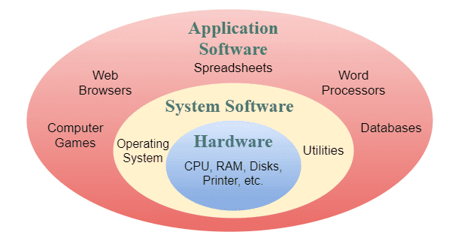

* + 1. **BUSINESS EQUIPMENT /TECHNOLOGY**

Business equipment is tangible property used in a business. Equipment is considered more permanent and longer lasting than supplies, which are used up quickly. Business equipment include but not limited to Fax machine, Telephone system including answering machines, Printer, Photocopier, Shredder and Binding equipment.

**Fax machine**

The facsimile machine (commonly referred to as a ‘fax’ machine) is used to transmit a copy of a document to someone located in another location, which also has a fax machine. The message is transmitted via a telephone line. Most organizations have a dedicated fax line so as to not hold up their incoming or outgoing telephone calls.

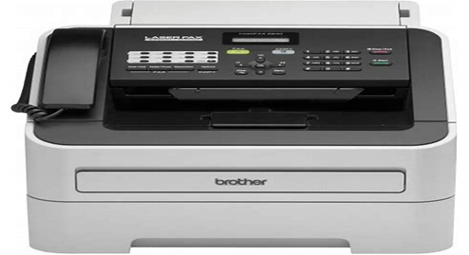

**Figures –1.1- Fax machine**

**Telephone System**

The telephone system will vary from organization to organization. Small businesses may have one incoming telephone line and one handset through to several incoming lines and several handsets. Large organizations may have an electronic switchboard or software program that enables all telephone calls to be managed via a computer.

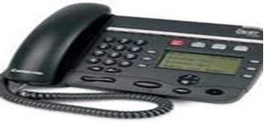

**Figures –1.2-Telephone System**

**Printers**

Printers are used to reproduce documents created, retrieved or received via a computer. A printer can be used to print a word-processed document, a worksheet in a spreadsheet program, database report, presentation slide, email, or information from the Internet. Where a computer has facsimile software installed, the computer can be used as a fax machine and the printer can print a copy of all fax messages sent and received.

* Direct thermal label printer

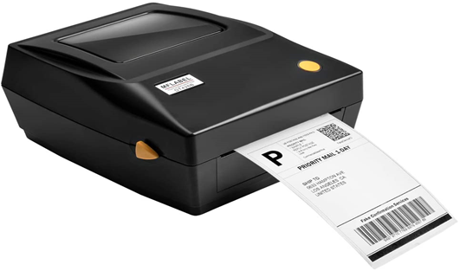

**Figures –1.3- printer**

* Automatic screen printing machine

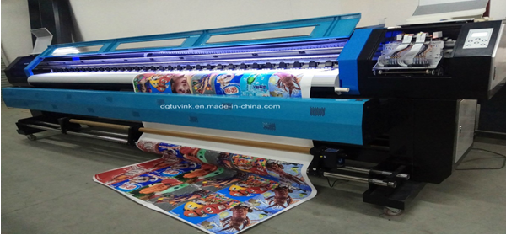

**Figures –1.4 - Automatic screen printing machine**

* T-shirt printer machine

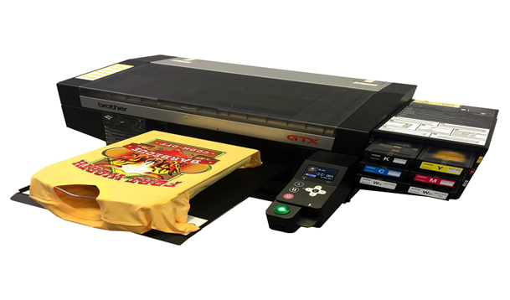

**Figures –1.5 - T-shirt printer machine**

* Press digital label

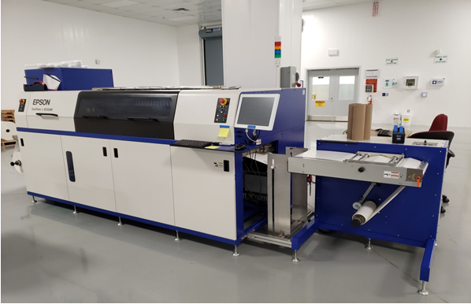

**Figures –1.6 - Press digital label**

**Printers can be**:-

**Impact printers**, such as dot matrix, where letters or characters are produced through a series of dots printed onto the paper. Impact printers tend to be noisy but are inexpensive to operate and maintain.

**Non-impact printers**, such as a laser printer, where powder is discharged from a cartridge inside the printer to make up the characters or letters to be printed; an ink-jet printer (or bubble jet), where ink is discharged onto the paper to create the letters or characters. Non-impact printers are more expensive to maintain and operate than an impact printer and they provide a good result.

Printers can print black images or full color images. Printing in color can be expensive so you should be very careful when printing in color to ensure you are not wasting the ink or toner.

**Photocopier**

Photocopiers are used to make copies of:

* Documents that may need to be read by more than one person
* Pages from books or journals
* Articles from newspapers
* Fax messages received on thermal paper.

Photocopiers can be basic – providing an option to produce a copy of the document in its original form. Photocopiers can also offer a range of other options.

**Figures –1.7- Photocopier**

You can use a photocopier to:

* 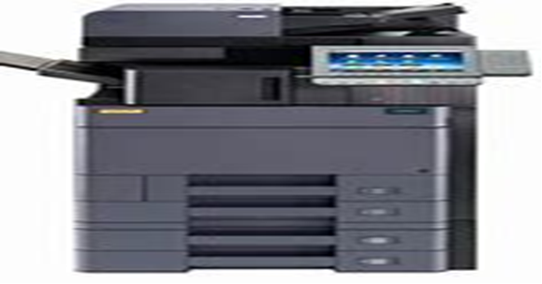Enlarge an image
* Reduce an image
* Sort a document of many pages into sets or separate duplicates of each page
* Staple documents
* Produce a document printed on both sides of the page
* Produce a document in colour.

All users of the photocopier should be aware of the Copyright Act (1968) Common wealth, which stipulates the rules for copying works produced by other people, such as authors, artists, animators and designers.

**Shredder**

There are often many confidential documents printed in an office. When the organization wants to get rid of these, they use a shredder, rather than placing them in the rubbish bin or the recycled paper bin. The shredder cuts these documents into very thin strips that are hard to read.

Follow safety procedures when operating a shredder. Be very careful. Keep your hair and clothes away from the shredder as they may get caught. Don’t put your hands anywhere near the slot where you place the paper.

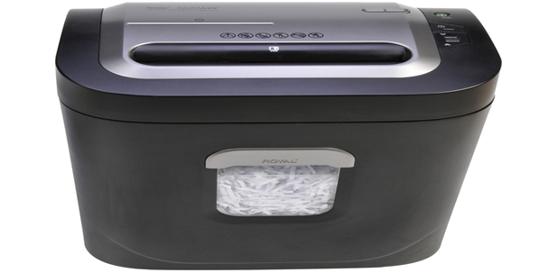**Figures –1.8 - Shredder**

To shred paper, take a few pages at a time and feed them slowly into the machine. Generally, only five pages are the most you should put in at a time. The machine will cut them into narrow strips.

When the bin is full of shredded paper, turn the shredder off and lift its top off. Do this very carefully because the top is very heavy. Empty the bin.

**Binding equipment**

There are lots of different ways you can join paper to make a book. A quick and easy method is to use staples, paper clips or fold-away clips.

However, you may be asked to present the material in a file or put covers on it to make it more secure and give the document a more professional look. When material is bound, it becomes stronger, which is important if a lot of people are handling the material. You can bind pages with special binding machines.

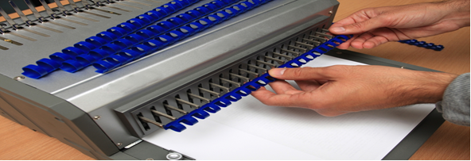

**Figures – 1.9 - Binding**

Organizations will have a range of binding equipment depending on the number of documents that need to be presented in this way.

**Stapling machine**

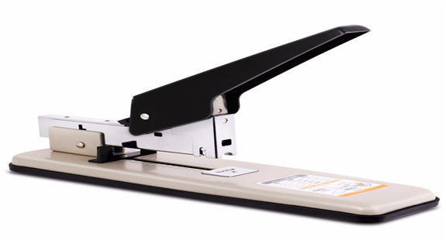

**Figures –1.10 - Stapling**

A stapling machine can be manual, electronic or part of the function on a photocopier. Staples are available in many thicknesses. If you have a lot of pages to bind together, you will need very strong, large staples.

* Hole punch or paper drilling machines



**Figures –1.11 - paper drilling machines/ Hole punch**

Using a small manual hole puncher, holes can be punched down the side of a document so it can be placed in a ring binder. If there are a lot of copies to make, and if the pages are very thick, some organizations use an electric drilling machine. Hole punches can sometimes be adjusted to punch two, three, four or five holes in a page.

* Heat binder

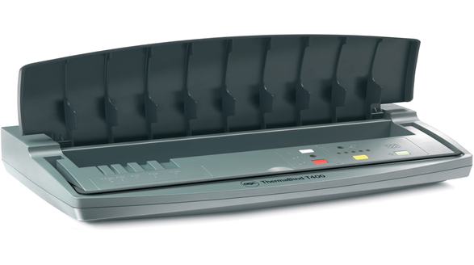

**Figures-1.12 - Heat binder**

An electric heat-binding machine uses heat to bind a document between specially glued covers. The finished product looks very professional.

* Comb binder

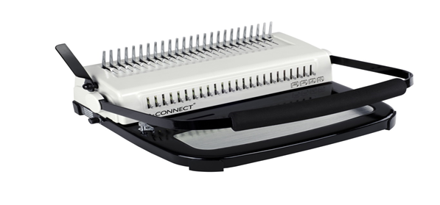

**Figures-1.13 -Comb binder**

A comb binder uses plastic or wire combs to join pages together. A plastic cover is often used for the front, and a thick card for the back. Reports are often bound using a comb binder.

* Guillotine

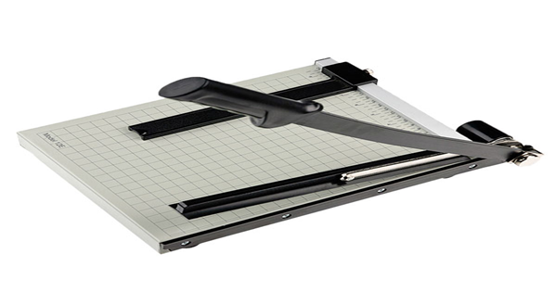

**Figures-1.14 - Guillotine**

A guillotine is used to trim the edges of a document before binding it or to cut pages to a particular size.

**1.2.1 Business Technology**

Commercial or business applications Computers are needed to perform business operations that require handling large amounts of data. Several computer applications are available to assist business in working with large volumes of data.

Examples are :-

* Text processing
* Accounting and Finance management
* Inventory control
* Database management

**Technology includes:**

* Computer technology laptops & Pc
* Digital camera
* Modems
* Printers
* Scanners
* Zip drives
* Photocopiers
* Shredders
* Binders
* Laminators
* Cutter

Computers will be examined first as they have become essential in workplaces. Here is a basic outline of personal computers and laptops, and the benefits of using both.

**Personal computers**

A computer is an electronic device for storing and processing information. A personal computer has a separate hard drive and monitor that are attached to other equipment such as a keyboard and mouse. Personal computers are used in all organizations to carry out many different tasks. Organizational data is usually processed using a computer and different software applications.

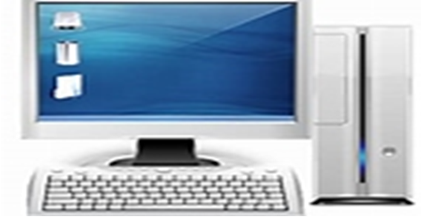

**Figures-1.15 - Personal computers**

**Laptops**

A laptop is a small, portable computer that has its hard drive, screen and keyboard within the same piece of equipment. Laptops are popular as they are portable, lightweight and don’t solely rely on a plug-in power supply (they have rechargeable batteries). However, laptops have disadvantages. Their small size makes them easy to steal, and they are not adjustable and, therefore, not as comfortable to use unless a separate laptop stand is available.

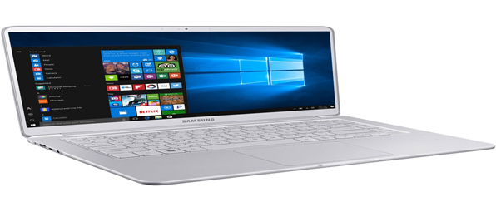

**Figures-1.16 - Laptops**

**Tablets**

A tablet PC is a truly portable computing tool. It is as powerful as a modern PC, but it doesn’t require a keyboard. Instead, using “digital ink” technology, you can add information by writing on the screen (or “tablet”) with a digital pen or “stylus,” much like you do in a patient’s paper chart.

**Types of tablet PCs**

1. **Slate tablet PC**



**Figures-1.17 - tablet**

A tablet with no attached keyboard (though one can be added)

1. **Convertible tablet PC**

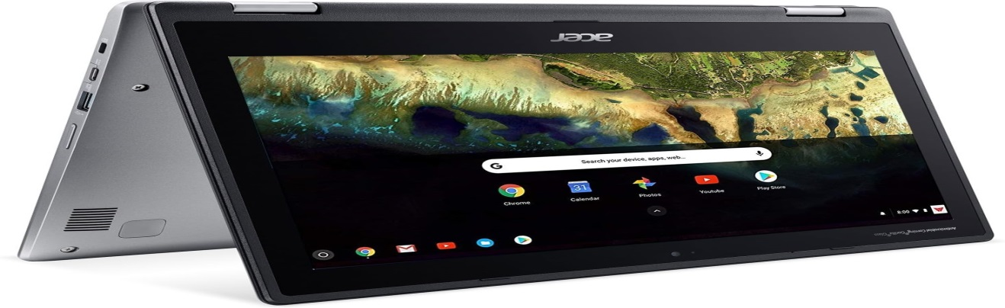

**Figures-1.18 - Convertible tablet**

**1.2.1. Requirement of ergonomic**

The word “ergonomics” comes from the Greek word “Ergon” which means work and “Nomos” which means laws. You can think of it this way; ergonomics is the science of designing the workplace, keeping in mind the strengths and weaknesses of the human body. Ergonomics is about creating comfortable conditions to work in. It is concerned with fitting the job to the worker, rather than the worker to the job. This is done by adapting workstations, tools and equipment to suit each worker’s individual needs.

Ergonomics is a wide-ranging field that seeks to design tools, equipment and tasks to optimize

human capabilities. Several catchphrases are described below that serve as good definitions. As you will see, in many ways, ergonomics is not really anything new. It amounts to seeing everyday things from a new perspective that is, putting on your “ergonomics glasses.” Much of ergonomics is common sense, once you think about it. The field can be summarized in a set of basic principles, which form the core of this booklet. Ergonomics is the science of work. Taking a scientific approach allows us to objectively measure workplace risk factors that lead to fatigue, discomfort and pain for workplace athletes. Ergonomic may include:-

* Avoiding radiation from computerscreens
* Chair height, seat and back adjustment
* Ddocuments holder
* footrest
* keyboards and mouse position
* lighting
* noise minimization
* posture
* screen position
* workstation height and layout

The goal of ergonomics is to make work more comfortable and to improve both health and productivity. Many ergonomic problems can be fixed by rearranging, adjusting or modifying existing furniture and tools, so don't be in too much of a rush to go out and purchase the next great ergonomic "THING".

One of the easiest to follow guidelines for any office set up is Office wise - A guide to health and safety in the office Developed by the Ergonomics Unit Victorian Work Cover Authority.

**Risk factors of Ergonomic are:-**

**Awkward Postures**

Awkward postures place excessive force on joints and overload the muscles and tendons around the effected joint. Joints of the body are most efficient when they operate closest to the mid-range motion of the joint. Risk of MSD is increased when joints are worked outside of this mid-range repetitively or for sustained periods of time without adequate recovery time.

**High Force Requirements**

Many work tasks require high force loads on the human body. Muscle effort increases in response to high force requirements, increasing associated fatigue which can lead to MSD.

**Repetitive Motions**

 Many work tasks and cycles are repetitive in nature, and are frequently controlled by hourly or daily production targets and work processes. High task repetition, when combined with other risks factors such high force and/or awkward postures, can contribute to the formation of MSD. A job is considered highly repetitive if the cycle time is 30 seconds or less.

Ergonomics is important because when you’re doing a job and your body is stressed by an awkward posture, high force requirement, and/or repetitive motions, your musculoskeletal or “movement” system is affected. Bad ergonomics increases fatigue in your soft tissues and your body may begin to have symptoms such as fatigue,

* + 1. **Ergonomic Equipments**

Workspace, furniture and equipment are adjusted to suit the ergonomic requirements of the user

**Chair**

* Chair height should be set so that feet are flat on the floor (where a footrest has not been provided) and thighs are horizontal.
* The backrest should provide firm lower back support so adjustment up or down, and/or backwards or forwards may need to be made until comfortable.
* Armrests should not interfere with performance of general tasks.

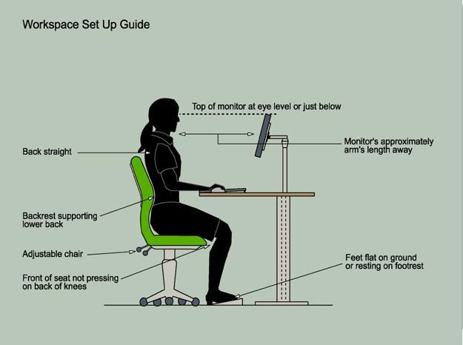

**Figures-1.20 - Workspace set up**

**Desk**

* The height of the desk or chair should be adjusted so that the surface of the desk is at elbow height (when sitting).
* There should be plenty of room for legs below the desk surface
* Personal and stationery items should be arranged for easy access, to minimize twisting and bending.



**Figures-1.21- Desk**

**Computer**

* The monitor should be positioned after adjustments have been made to the desk or chair. It is recommended that the top of the screen be level with the eyes and be positioned about 50cm away from the body when seated.
* The keyboard should be placed on the desk, as close to the user as possible. Allow room for it to be moved away when not in use. The angle of the keyboard can be adjusted by altering the supports underneath.
* The mouse should be positioned next to the keyboard on the preferred side. Wrist should be straight whilst using the mouse with the desk supporting the wrist and not the arm.

**Telephone**

* The telephone should be easily accessible, yet not in the way of the work area.
* The user should be able to talk on the phone without standing or having to stretch to reach it. A headset is a convenient alternative for constant phone users.

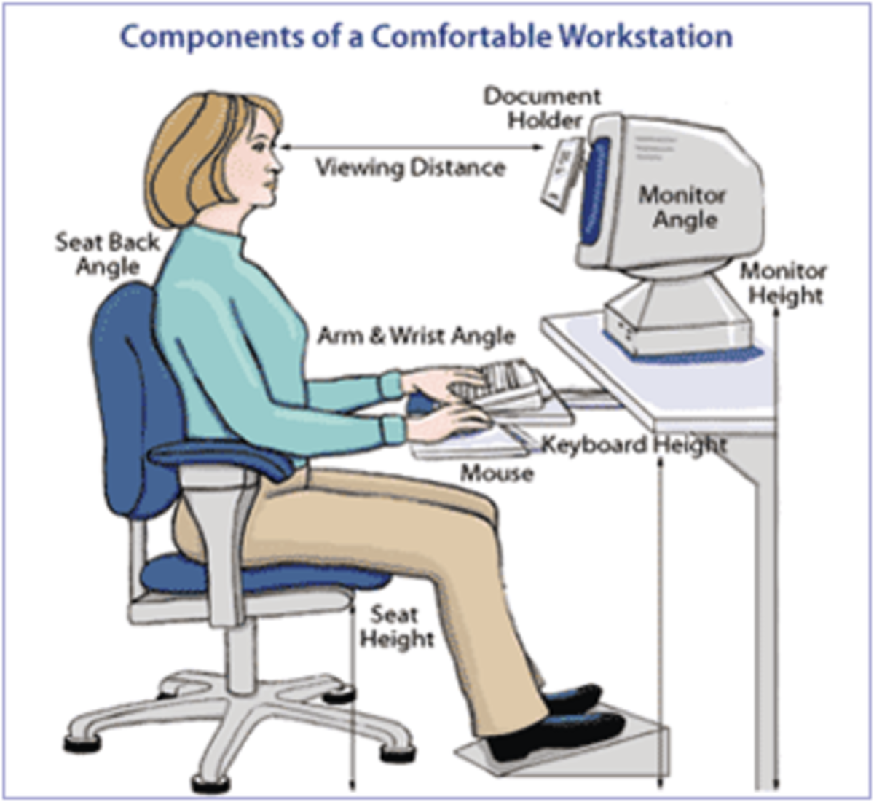

**Figures 1.22 - Telephone layout**

**Document holder**

* The document holder should be placed close to the screen to minimize the movement required to turn from one to the other.
* Depending upon personal preference, it may be preferable to swap the screen position with the document holder, if tending to look at the document more often.

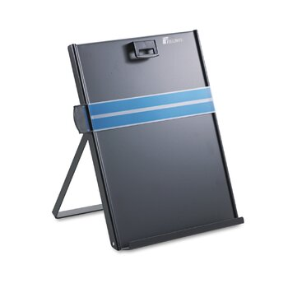

**Figures** 1.23 - Document holder

**Work Organization**

Work organization meets organizational and occupational health and safety requirements for computer operation

**Work Organization**

Work organization meets organizational and occupational health and safety requirements for computer operation

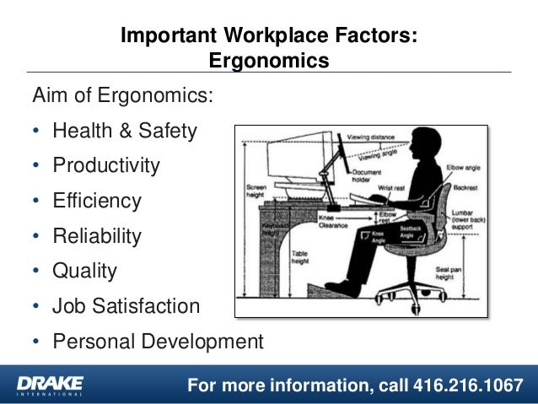

**Figures - Work Organization**

**Work area**

* Work area should be kept uncluttered. Desks should only have on them what is really needed.
* Trays should be used for sorting documents, and any documents that are finished with or will not be needed for some time, should be filed away.

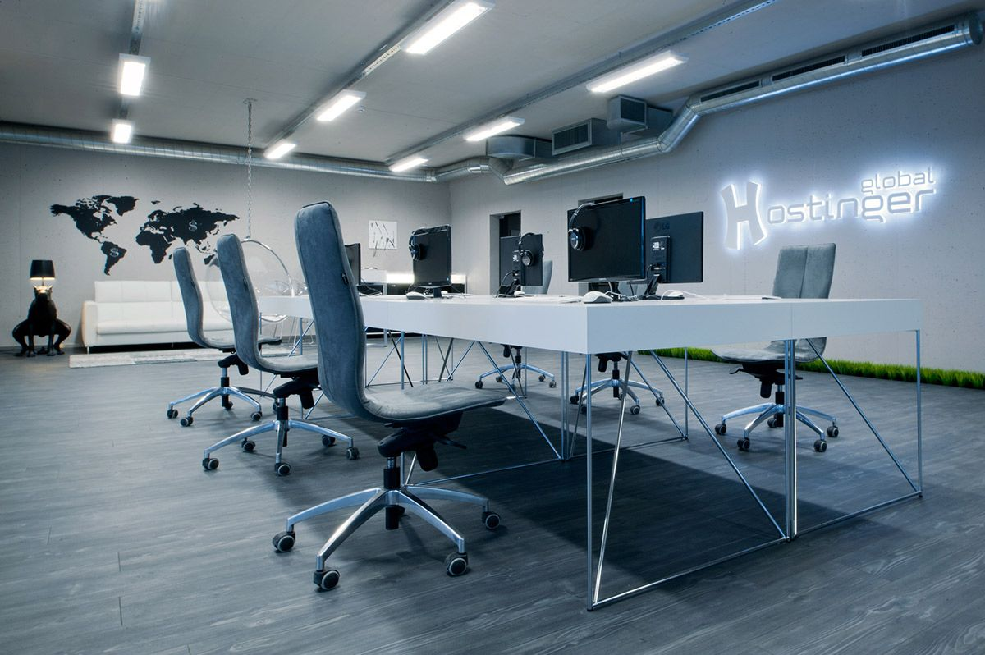

**Figures -Work area**

**Rest periods**

* It is important to have frequent breaks away from the workstation. The recommended interval is ten minutes for each hour worked in front of a computer.
* If unable to take this time out, work tasks should be varied. For example, phone calls could be made; filing or other work related tasks could be done for a few minutes.



**Paper wastage**

* Proofread and edit documents on screen before printing
* Don't print more pages than needed, use the "print range" function of software to only print those pages which have been edited
* Print on both sides of your paper where possible
* Use scrap paper from printed documents no longer needed. Write on the back for informal notes or memos
* Use the duplex facility of the photocopier.

**Recycling**

* Paper should be saved for recycling where possible - if the information is confidential, it can be shredded before disposal into a recycling container
* Use recycled paper products wherever possible
* Reuse office products such as folders, envelopes and packaging materials.

**Energy and power use**

* Use the "power save" feature of your printer, if available
* Switch off lights and equipment when not required.
* promote - the giving and receiving of systematic instruction, the process of facilitating learning, constituted from countless methods, tools, and structures, operated by teachers and many others – may usefully be seen as a technological phenomenon; that all educators are thus educational technologists (albeit that their choices of technology may vary); and that this has some very far reaching consequences for research and practice, explaining some hitherto puzzling phenomena, and challenging some of the fundamental beliefs held by many educators and researchers in education

**Using technology**

Ways in which technology has become an integral part of everyday work:

* Communications technologies
* Office productivity
* Record keeping and retrieval.
* Internet and search
* Analytics and new decision structures
* Automation, robotics and future factories
* Adoption of virtual and augmented reality
  1. **Using and Promoting technology**

The use of entertainment technology entertainment is beneficial for creating and improving an entertaining experience in human life. As the field of entertainment is way too broad, hence everyone has their form of getting entertained. Social media is a computer-based modern technology people use to interact and share with other users in their networks. This can be done through virtual interactions such as building communities. Electronics technology is a part of the fabric of our lives. social media has become a significant part of our society

The term ‘technology’ is, as, an ‘annoyingly vague abstraction,’ with many fuzzy, shifting, evolving, inconsistent, and sometimes contradictory meanings. There is widespread agreement that technologies do things for us, or help us to achieve our purposes “the way we do things”, implying regularized structuring and organization of objects, concepts, and so on in order to achieve those purposes. Part of the problem, though, is that technology can be both something that we do and something that has been done, often simultaneously.

**UNIT TWO :- PROCESSING AND ORGANIZING DATA**

This learning guide is developed to provide you the necessary information regarding the following content coverage and topics:

* Identifying and Generating records
* Operating Input devices
* Storing data
* Using training manuals tools

**2.1 Identify and generate records**

The skill of recording data involves the documenting of data and observations in a variety of forms in order to preserve it for later use. promotes the development of a wide range of written, oral, visual and digital literacy skills involved in documenting and organizing information, including: sketching , Labeling, note-taking, journaling, photographing, videotaping, etc. Develops skills involved with the gathering and organizing of qualitative and quantitative observations and data to make it useful for analysis and interpretation.

**Definition of Records**

Document that memorializes and provides objective evidence of activities performed, events occurred, results achieved, or statements made. Records are created/ received by an organization in routine transaction of its business or in pursuance of its legal obligations. A record may consist of two or more documents. All documented information, regardless of its characteristics, media, physical form, and the manner it is recorded or stored. Records include accounts, agreements, books, drawings, letters, magnetic/optical disks, memos, micrographics, etc. Generally speaking, records function as evidence of activities, whereas documents function as evidence of intentions.

**Records Management**

The [records life-cycle](https://en.wikipedia.org/wiki/Records_life-cycle) consists of discrete phases covering the life span of a record from its creation to its final disposition. In the creation phase, records growth is expounded by modern electronic systems. Records will continue to be created and captured by the organization at an explosive rate as it conducts the business of the organization. Correspondence regarding a product failure is written for internal leadership, financial statements and reports are generated for public and regulatory scrutiny, the old corporate logo is retired, and a new one – including color scheme and approved corporate font – takes its place in the organization's history.

Examples of records phases include those for creation of a record, modification of a record, movement of a record through its different states while in existence, and destruction of a record.

Throughout the records life cycle, issues such as security, privacy, disaster recovery, emerging technologies, and mergers are addressed by the records and information management professional responsible for organizational programs. Records and information management professionals are instrumental in controlling and safeguarding the information assets of the entity. They understand how to manage the creation, access, distribution, storage, and disposition of records and information in an efficient and cost-effective manner using records and information management methodology, principles, and best practices in compliance with records and information laws and regulations.

**Characteristics of records**

* Records are evidence of actions and transactions
* Records should support accountability, which is tightly connected to evidence but which

allows accountability to be traced

* Records are related to processes, i.e. “information that is generated by and linked to work

processes”

* Records must be preserved, some for very short time and some permanently.

**2.2 operating input devices**

An **input device** is any [hardware](https://www.computerhope.com/jargon/h/hardware.htm) device that sends data to a computer, allowing you to interact with and control it. The picture shows a [Logitech](https://www.computerhope.com/comp/logitech.htm) [trackball](https://www.computerhope.com/jargon/t/trackbal.htm) mouse, which is an example of an input device. The most commonly used or primary input devices on a computer are the [keyboard](https://www.computerhope.com/jargon/k/keyboard.htm) and [mouse](https://www.computerhope.com/jargon/m/mouse.htm). However, there are other devices that input data into a computer.

**Inputs**

Input is a place where, or a device through which, energy or information enters a system. or An input device is any hardware device that sends data to a computer, allowing you to interact with and control it. ... The most commonly used or primary input devices on a computer are the keyboard and mouse. However, there are dozens of other devices that can also be used to input data into the computer.

**Data**

Unprocessed facts, figures, and symbols

Instructions

* Programs
* Commands
* User response

The Keyboard divided

* Typing area
* Numeric keypad
* Function keys

Key board ergonomic

Designed to minimize strain on hands and wrists. Ergonomics incorporates comfort, efficiency, and safety into design of items in workplace.

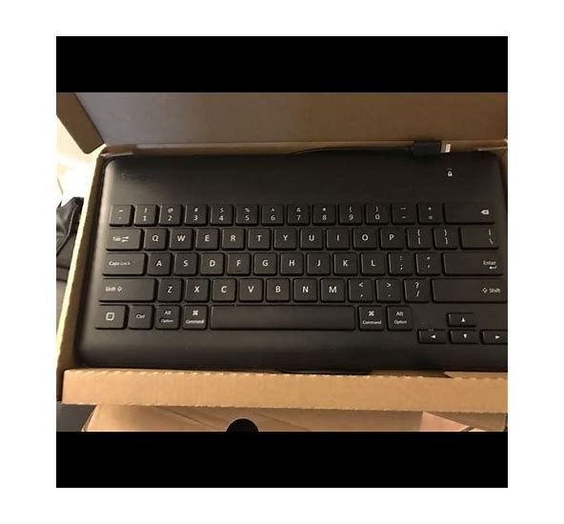

**Figures 2.1- Key board ergonomic**

**Mouse**

• Pointing device that fits under palm of hand

• Controls movement of pointer, also called mouse pointer, on screen

• Pointer on screen takes several shapes

**Common mouse operations**

* Point
* Click
* Right-click
* Double-click
* Drag
* Right-drag
* Rotate wheel
* Press wheel

**2.3 Storing data**

In business, there are many natural, hierarchical relationships among data. Databases (DB) are used by organizations to collect information in one consolidated place for easy access, management, and update. The data collected could be personal information about customers from online store (name, address, and phone), inventory (product, quantity, and price), orders (date, product, and shipping address) or anything the business needs to track. It’s up to the user to determine what data needs to be aggregated and the format it will take. The most common type of DB storage structures are Relational Databases where the data is stored in relations, taking the form of tables made of columns (fields) and rows (records/items). These tables are connected within a database. To access and interact with the data, the user needs database management system (DBMS), such as Oracle DB, Microsoft SQL, IBM DB, SAP DB, etc.

The DB market is huge and constantly growing: analysts are projecting it to reach $60B by 2022. Given the continued expansion of the database applications, Info trend fulfils the demand for more storage requirement. It’s of high importance for DB storage to be able to support multiple and random real-time inquiries/transactions from clients. Online Transaction Process (OLTP) must be highly stable, high IOPS for small block size data and random reads & writes is required. Moreover, the storage must be expandable, i.e. show high scalability without performance degradation. And finally, it should be highly manageable and cost-effective Other than on the hard drive, data may also be stored on.

* floppy disks: remember that a limited amount of information can be stored here, so it is a good idea to compress the file to accommodate large amounts of data
* CD-ROMs: suitable for large amounts of data
* back-up system: particularly important in case of computer failure to safeguard large amounts of information
* External hard drives
* Thumb drives

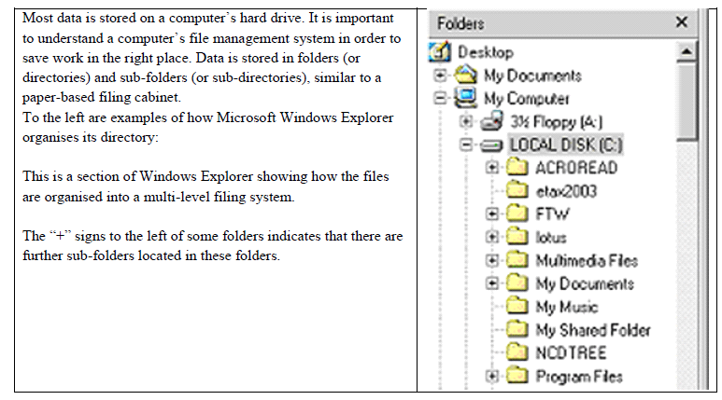

**Figures -2.2 - store data**

* floppy disks: remember that a limited amount of information can be stored here, so it is a good idea to compress the file to accommodate large amounts of data
* CD-ROMs: suitable for large amounts of data
* back-up system: particularly important in case of computer failure to safeguard large amounts of information
* External hard drives
* Thumb drives

1. **Retrieving Documents**

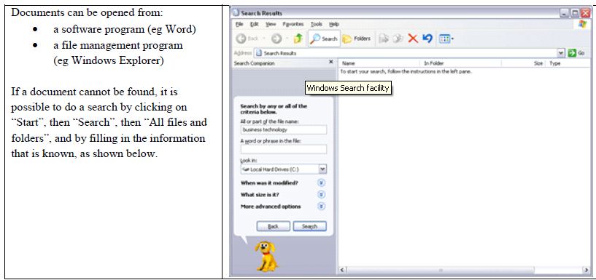

**Figures 2.3 - retrieving document**

1. **Data Files**

Data files are the operating system files that store the data within the database. The data is written to these files in an Oracle proprietary format that cannot be read by other programs. Temp files are a special class of data files that are associated only with temporary table spaces.

Data files can be broken down into the following components:

* **Segmen**t: - A segment contains a specific type of database object. For example, a table is stored in a table segment, and an index is stored in an index segment. A data file can contain many segments.
* **Extent** is a contiguous set of data blocks within a segment. Oracle Database allocates space for segments in units of one extent. When the existing extents of a segment are full, the database allocates another extent for that segment.
* **Data block** also called a database block, is the smallest unit of I/O to database storage. An extent consists of several contiguous data blocks. The database uses a default block size at database creation.

After the database has been created, it is not possible to change the default block size without re-creating the database. It is possible, however, to create a table space with a block size different than the default block size.

Segments, extents, and data blocks are all logical structures. Only Oracle Database can determine how many data blocks are in a file. The operating system recognizes only files and operating system blocks, not the number of data blocks in an Oracle Database file. Each data block maps to one or more operating system blocks.

There are three types of table spaces:

* Permanent: - You use permanent table spaces to store your user and application data. Oracle Database uses permanent table spaces to store permanent data, such as system data. Each user is assigned a default permanent table space.
* Undo: - a database running in automatic undo management mode transparently creates and manages undo data in the undo table space. Oracle Database uses undo data to roll back transactions, to provide read consistency, to help with database recovery, and to enable features such as Oracle Flashback Query. A database instance can have only one active undo table space.
* Temporary: - table spaces are used for storing temporary data, as would be created when SQL statements perform sort operations. An Oracle database gets a temporary table space when the database is created. You would create another temporary table space if you were creating a temporary table space group. Under typical circumstances, you do not have to create additional temporary table spaces. If you have an extremely large database, then you might configure additional temporary table space.
  1. **Using training manuals tools**

Truth be told, developing online training programs for an organization is anything but an easy task; improving your skills as a trainer, on the other hand, is much easier when you know where to start from.

Maybe a change in your mentality, training and development tools that might have flown under your radar or some more empathy could do the trick. In any case, this is the guide you’ve been looking for.

In this article, you’ll get to know all the necessary training skills that trainers should have in order to transfer knowledge and enjoy a successful career in the training industry. What’s more, you’ll get to know the best tools for training that trainers can use to simplify their workload and make their courses shine.

To save time, here are the essential skills for trainers:

* [Advanced research skills](https://www.talentlms.com/blog/essential-skills-training-tools-for-trainers/#1_Advanced_research_skills)
* [Strong communication skills](https://www.talentlms.com/blog/essential-skills-training-tools-for-trainers/#2_Strong_communication_skills)
* [Organizational skills](https://www.talentlms.com/blog/essential-skills-training-tools-for-trainers/#3_Organizational_skills)
* [Adaptability skills](https://www.talentlms.com/blog/essential-skills-training-tools-for-trainers/#4_Adaptability_skills)
* [Enthusiasm for lifelong learning](https://www.talentlms.com/blog/essential-skills-training-tools-for-trainers/#Enthusiasm%20for%20lifelong%20learning)

**The essential skills for trainers**

Every trainer needs to have specific skills as well as training and development tools to be effective. First, let’s look at the following list that includes both soft training skills and hard.

**Advanced research skills**

Searching on Google has a lot of secrets, some of which you’re going to find out in a bit. For example, do you know how to use Boolean operators and symbols in your searches?

This type of advanced Google searching can help you find relevant and reliable content and [create online courses](https://www.talentlms.com/create-online-courses) in half the time. Also, you will be able to find websites that you may haven’t heard before but feature information and content that might be useful even in the long run.

However, you need to evaluate websites as well as critically assess research papers. To check whether a website you are visiting is worthy of your attention, all you have to do is browse through all menu items and check the footer for the last date it was updated.

**Strong communication skills**

Training is about people (also known as human beings). What makes us different from the rest of the living organisms is that we have the ability to communicate with each other in a direct manner. This is why one of the essential trainer qualities and skills you need to be an effective trainer is communication. In fact, it can easily make or break the learner’s experience.

**Organizational skills**

Strong organizational skills always get you far. Both as a trainer and a person. Skills like managing your time will help you stay on track. In learning, training, and development, trainers need to complete various tasks before they deploy a training program. From collecting all the materials required to delivering training efficiently, mastering organization is vital.

Another critical skill for trainers that is totally related to organization is problem-solving. The truth is that the more organized you are, the more problems you will have solved proactively. This will lead to an excellent learner experience since you will have taken care of everything beforehand. Plus, less stress for you.

**4. Adaptability skills**

Things don’t always turn out the way we expect ; Sometimes life gets in the way. Delays, troubles, and unforeseen circumstances can simply happen. So, what can you do? As a trainer, you need to be prepared for the unexpected. Which, of course, means that you have to be adaptable? Have a plan B for almost everything, play around with your tools and see how some features can help you prepare. Second-guess yourself and think of anything that could possibly go wrong. Now, fix it before it even happens. And before you even know it, adaptability will turn from a training skill into a personality trait.

**5. Enthusiasm for lifelong learning**

Learning should never stop for a trainer. As part of the training industry, you must develop [lifelong learning](https://www.talentlms.com/solutions/lifelong-training-software) habits so that you can keep up with all the advancements in a market that keeps changing. But another reason why you need to invest in lifelong learning as a trainer is to be able to empathize with your learners and put yourself in their shoes.

Sometimes when trainers build courses on a daily basis, they tend to forget what it really feels like to be learning something new. There’s fear, frustration, excitement, fatigue *(yes, it happens!)*, boredom, and so much more that goes through your learners’ minds.

And, from time to time, you need to see through your learners’ eyes to be an effective trainer to create engaging, fascinating courses. From all these skills for trainers, this one might be the most important. Keep learning, so you never forget what it’s like to be a learner.

Followed by the must-have tools for trainers in categories:

* [Learning Management System (LMS)](https://www.talentlms.com/blog/essential-skills-training-tools-for-trainers/#1_Learning_Management_System_LMS)
* [Content authoring tool](https://www.talentlms.com/blog/essential-skills-training-tools-for-trainers/#2_Content_authoring_tool)
* [Video editing software](https://www.talentlms.com/blog/essential-skills-training-tools-for-trainers/#3_Video_editing_software)
* [Social media](https://www.talentlms.com/blog/essential-skills-training-tools-for-trainers/#4_Social_media)

Here are the four main categories of training and development tools every trainer should have in their toolbox:

**Learning Management System (LMS)**

The best training tools for trainers who want to create courses, manage users, and track the performance of their online training and learners Management System).Trainers should not only know how to use an LMS. They should know how to make the best out of it without the hassle.

Content authoring tool

To understand the value of eLearning authoring tools, you need to understand what an authoring tool really is. In essence, authoring tools are software platforms that let trainers add a variety of media and multimedia files to create engaging training. If you want to build [interactive courses](https://www.talentlms.com/blog/how-create-interactive-online-training-program/),

for example, an e- Learning authoring tool sounds like the best way to go. However, there’s another, easier solution**.**

Right now, there are many Learning Management Systems that come with built-in authoring tools so you don’t have to switch between platforms to deliver high-quality training. You simply create your account, access your training hub, and start building your course right away.

**Video editing software**

One of the most overlooked training tools for trainers is videoediting software. The reason why videos are powerful is that they offer a vivid andengaging learning experience, Play around with various video types to rock your courses.

**Video editing formats :-**

* Talking head videos
* Screen-recordings
* Video presentations
* Documentary-like videos
* And many more.

**Social media marketing**

Social media marketing (SMM) (also known as digital marketing and e-marketing) is the use of [social media](https://www.investopedia.com/terms/s/social-media.asp)—the platforms on which users build [social networks](https://www.investopedia.com/terms/s/social-networking.asp) and share information to build a company's brand, increase sales, and drive website traffic. In addition to providing companies with a way to engage with existing customers and reach new ones, social media marketing (SMM) has purpose-built [data analytics](https://www.investopedia.com/terms/d/data-analytics.asp) that allow marketers to track the success of their efforts and identify even more ways to engage.

social media and social networks to market products and services, engage with existing customers, and reach new ones. The power of social media marketing comes from the unparalleled capacity of social media in three core marketing areas: connection, interaction, and customer data.

Social media marketing has transformed the way businesses are able to influence consumer behavior—from promoting content that drives engagement to extracting personal data that makes messaging resonate with users. Because social media today is so ubiquitous, marketing techniques using these platforms are extremely important for businesses.

**UNIT THREE:-MAINTAINING TECHNOLOGY**

This learning guide is developed to provide you the necessary information regarding the following content coverage and topics:

* Using technology consumable
* Arranging routine maintenance
* Identifying faults of equipment

Correct utilization rates reduce the capital investment costs and care must be taken to make as accurate a calculation as possible. Besides information on lifespan and maintenance requirements, utilization also determines the rate at which consumables are used. If equipment is to keep functioning, you must ensure that reasonable stocks of consumable items are held at all times, and that these form part of recurrent budgets. You therefore need to calculate the usage rates for equipment-related consumable items. By doing this, you can base your recurrent budgets on the actual ‘lifetime costs’ (daily operational, maintenance and administrative requirements) of the items in your equipment inventory.

Recurrent budgets covering equipment-related consumable items are required to ensure that equipment continues to function. Equipment-related consumable items are:

**Technology consumables**

Consumables (also known as consumable goods, non-durable goods, or soft goods) are goods that

are intended to be consumed. Consumables are products that consumers use recurrently, i.e., items which "get used up" or discarded.

* Replacing Consumables
* Purchasing Items take into account**:-**
* Quality of products
* Quality of service
* Reliability of advice
* Promptness of delivery
* Reasonable return service when goods don’t work
* Purchasing Guidelines
* What employees are allowed to purchase
* Who can approve the purchase
* Declaration by purchaser of any dealings, connections/interests in chosen supplier fairness

Consume Technology

* Back-up tapes
* CD-ROM
* Floppy disks
* Print heads
* Printer ribbons and cartridges
* Toner cartridges
* Zip disks

**3.2 Arranging routine maintenance**

We are on the hunt for a talented and reliable maintenance technician to join our maintenance department. In this position, your chief responsibility is to preserve the excellent condition and functionality of our business premises. Your duties will include conducting quality assessments, scheduling repairs, maintaining inventory, and developing preventative maintenance procedures.

Our ideal candidate will be a jack-of-all-trades, with in-depth knowledge of maintenance procedures, hydraulic systems, and basic tools and appliances. To excel in this position, you must be an outstanding problem-solver with exceptional communication and organizational skills.

**Routine maintenance**

* ‘Preventive maintenance’ – reduces the chance of something going wrong
* Equipment works more often and workers become more productive
* In-house cleaning and servicing of equipment according to manufacturer's guidelines
* Periodic servicing by qualified or manufacturer approved, technician
* Regular checking of equipment
* Replacing consumables

**Non-Routine Maintenance**

* Fixing something after it is broken or not working properly
* The more you carry out routine maintenance the less likely you will have to carry out non-routine

It is important that routine maintenance of business technology is carried out on a regular basis to ensure minimal breakdowns. Equipment should be cleaned regularly by using a damp cloth or other approved cleaning materials. Consumables should be checked to monitor their rate of use, and replaced when needed. Regular servicing by qualified or manufacturer-approved technicians will ensure that all equipment is in the best condition possible to minimize breakdowns.

All employees should receive training to solve common faults, like paper jams, system failures and low ink or toner cartridges. However, more complex problems should be reported immediately to the person in charge of maintenance, to the manufacturer or to the service company. A logbook of service visits must be kept. It is a good idea to have all equipment checked regularly as part of the Occupational Health and Safety inspections.

**3.3Identify faults of Equipment**

Faults reserve the right to request that any specific remedial action be carried out (at the Customer’s cost) prior to attending to any [Equipment Fault](https://www.lawinsider.com/dictionary/equipment-fault). Faculty must provide any and all department-approved syllabi relevant to the education abroad program to the Education Abroad Office prior to the launch of the education abroad program's online application. Where an Equipment Fault has been logged and Comms FM have attended Site and no Equipment Fault exists on the Equipment then this is deemed to be an “Abortive Visit”. The BG should be emailed from the official email id of the Authorized Signatory of the Bid. Comms FM operate an allocation and scheduling system that priorities Equipment Faults according to severity of the Equipment Fault and the level of cover provided. Will endeavor to attend the Equipment Fault at the earliest opportunity within the Target Response Time .

**Equipment faults**

Equipment failure refers to any event in which any equipment can not accomplish its intended purpose or task, it may also mean that the equipment stopped working, is not performing as desired, or is not meeting target expectations.

Faults

* When an equipment fault is detected, read the manufacturer’s manual to identify the type of fault and the steps required to fix it.
* Do not try to fix any fault where the manual specifies that the manufacturer must be contacted. This may void the warranty or the service agreement.
* For minor faults, follow the manufacturer’s instructions closely to minimize further damage to the equipment. If you cannot fix a minor fault, follow the procedure for major faults.
* For major faults, complete an Equipment Fault Report. Submit the Equipment Fault Report to the Administration Officer who will notify the relevant equipment supplier.
* The Administration Officer will place an ‘Out of Order’ sign on the equipment item, showing when the fault will be rectified. The Administration Officer retains all Equipment Fault Reports as a record of an item’s reliability.

**Identifying equipment faults**

* Checking repairs have been carried out
* Encouraging feedback from work colleagues
* Keeping a log book of detected faults
* Preparing a maintenance program
* Regular back-ups of data
* Regular OHS inspections
* Routine checking of equipment

**Minor equipment faults**

|  |  |
| --- | --- |
| **Fault** | **Possible Solution** |
| **Photocopier** | |
| Spots or marks on the copy | Check the glass to see that it is clean. If not, clean with a special cleaner and use a soft cloth. |
| Jammed paper | Look at the display screen to locate the jammed paper.  Open that section and remove the paper. |
| Paper tearing | Remove the paper and if necessary, reset the paper feed guides on the tray. |
| Toner low | Fill up the toner with correct powder or replace the toner cartridge. |
| **Facsimile machine** | |
| Incorrect number for the receiver | Check you have the correct fax number and try again. You may need to telephone the organization to check the number. |
| Document not transmitting | Try again. If it is still not transmitting, call the receiver and ask them to check their machine for paper out, paper jam etc. |
| Blank paper received | Paper could have been inserted the wrong side up at the sender’s end or  If your fax machine uses thermal paper, the roll may be feeding in the wrong way up (it only prints on one side). |
| **Telephone** | |
| Voicemail message has disappeared | System my have been shut down and you therefore need to record your message again. |
| **Printer** | |
| Paper jammed | Check the display for the error message and search for the paper. Remove all parts of the paper as any stray pieces could block the pathway for paper feeding through. |

|  |  |
| --- | --- |
| Error message | This could be due to low toner or someone has set their paper source tray for Manual Feed and not automatic. Press continue button if available. |
| Toner is dropping on the page during printing | Replace the toner cartridge as it is getting low or it is a recycled toner cartridge with a poor seal. |
| Printer not printing | Check the online button as it should be on. |
| **Stapler** | |
| Jammed staples | Remove staples from the stapler – a staple remover is good for that – reload the staples and try again. |
| Staples not inserted correctly or completely into the paper | Remove staples from page using a staple remover – reload stapler with staples – place document on the table and try again. |